**ACF 11 – FINANCIAL STATEMENTS**

**EXTRA QUESTIONS**

**Required: Prepare classified financial statements for the businesses below, i.e. Flying Unicorns Stationery and Bolting Brumbies Hardware**

The following trial balance was supplied on 30 June 2020.

**Flying Unicorns Stationery**

**Trial Balance**

**As at 30 June 2020**

|  |  |  |
| --- | --- | --- |
| Account title | Debit | Credit |
| Cash at bank | 8 540 |  |
| Long term investment | 12 000 |  |
| Furniture | 28 000 |  |
| Capital – T. Blake |  | 37 200 |
| Prepaid insurance | 4 800 |  |
| Sales |  | 996 000 |
| Cost of sales | 796 100 |  |
| Accounts receivable | 17 400 |  |
| Stock | 11 380 |  |
| Bad debts | 880 |  |
| Allowance for doubtful debts |  | 2 000 |
| Gain on disposal of oak furniture |  | 9 820 |
| Rent | 12 000 |  |
| Accounts payable |  | 49 460 |
| Discount received |  | 8 600 |
| Utilities (water, electricity and gas) | 23 580 |  |
| Telephone | 5 000 |  |
| Wages | 121 600 |  |
| Drawings | 61 800 |  |
|  |  |  |
|  | **1 103 080** | **1 103 080** |

Additional information:

1. Staff are owed $2 000 wages.
2. The prepaid insurance was paid on 28 February 2020 and is a per annum fee.
3. The furniture is depreciated at 10% using the straight-line method. The furniture was purchased on 1 July 2019.

2. **Bolting Brumbies Hardware**

**TRIAL BALANCE AS AT 30 JUNE 2017**

|  |  |  |
| --- | --- | --- |
|  | **Debit** | **Credit** |
| Capital |  | 124 400 |
| Cost of sales | 1 592 200 |  |
| Accounts receivable | 84 800 |  |
| Inventory | 22 760 |  |
| Electricity | 1 760 |  |
| Loan |  | 4 000 |
| Gain on disposal of office equipment |  | 19 640 |
| Cash at bank | 17 080 |  |
| Wages | 243 200 |  |
| Drawings | 123 600 |  |
| Prepaid insurance | 9 600 |  |
| Sales |  | 1 992 000 |
| Shares | 24 000 |  |
| Office Equipment | 56 000 |  |
| Rent | 24 000 |  |
| Accounts payable |  | 98 920 |
| Discount received |  | 17 200 |
| Advertising | 47 160 |  |
| Discount allowed | 10 000 |  |
|  |  |  |
|  | **2 256 160** | **2 256 160** |

Information:

1. The office equipment is depreciated at 20% using the straight-line method. The office equipment was purchased on 1 July 2016.
2. Staff are owed $4 000 wages.
3. The prepaid insurance was paid on 1 June 2017 and is a per annum fee.
4. The business receives a sales order of $80 000 worth of inventory. The order is paid for and recorded by crediting sales and debiting the bank. The order will be delivered in equal instalments on 30 June 2017 and 30 September 2017.

**SOLUTION: Flying Unicorns Stationery**

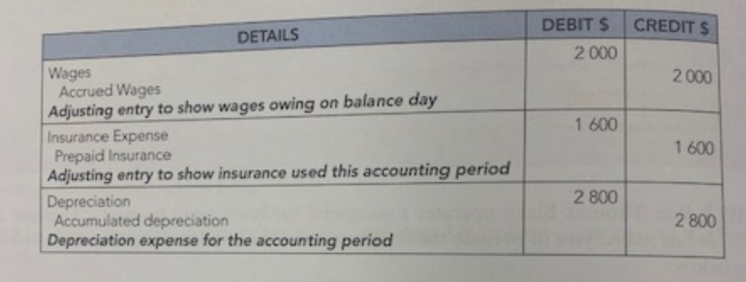

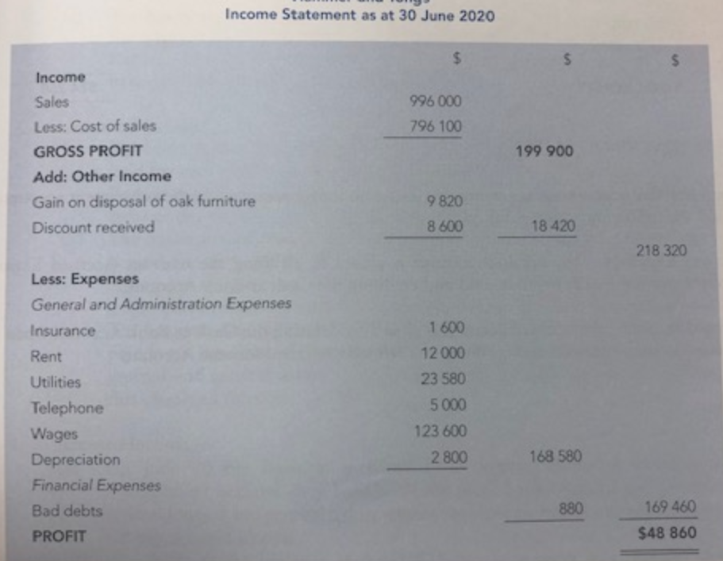

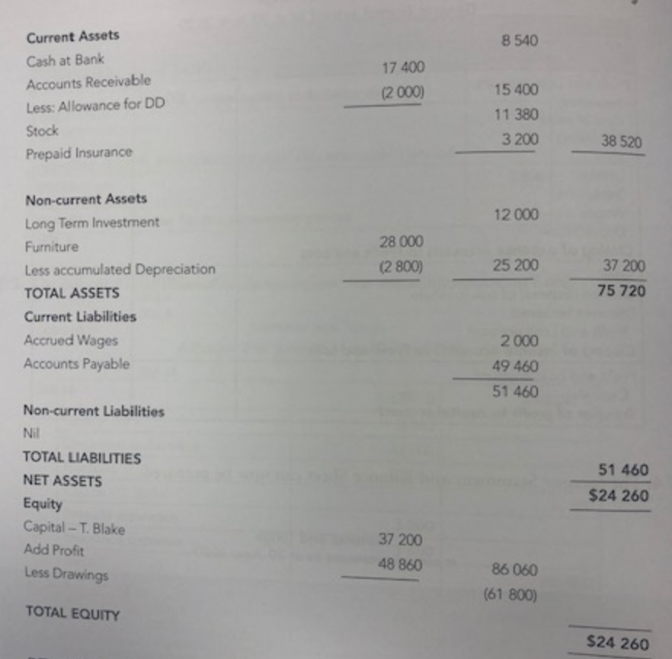

**SOLUTION: Bolting Brumbies Hardware**

